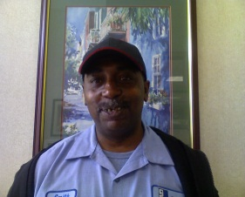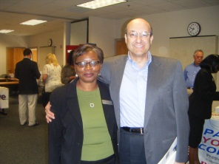

Vocational Team

The Vocational Staff for Charleston/Dorchester Mental Health in partnership with the South Carolina Department of Vocational Rehabilitation Services are:

Joyce Brown

Vocational Coordinator

Janice McKinney

Project Developer

Barbara Erby

Employment Specialist (IPS)

Marion Lawton

Employment Specialist (IPS)

Betsy Diffenderfer

VR Job Coach (IPS)

Nancy Elmore

Employment Specialist

Lloyd J. Hale II

Peer Support Specialist

Ginger Ash

VR Counselor

Queen Anderson

Benefit Specialist

## Charleston/Dorchester Mental Health

## Vocational Services Information

Employing the Community

# “Works for Everyone!”

**2100 Charlie Hall Boulevard**

**Charleston, SC 29414**

**Business Tel: 843-852-4100**

**Business Fax: 843-573-2393**

Joyce Brown, Vocational Coordinator

2100 Charlie Hall Boulevard

Charleston, SC 29414

Phone: 843.852.4100

Fax: 843.573.2393

Jab33@scdmh.org

## Individual Placement and Support (I.P.S.)

The Charleston/Dorchester Mental Health Center adopted the (I.P.S.) Individual Placement and Support Model in 2002, because its concept speaks to our belief about “mental Illness.” We believe that everyone can perform work tasks of some kind, preferably of their desire.

Our goal is to assist any consumer in establishing a career of their choice. The Individual Placement and Support Model (I.P.S.) utilize all support systems to help a consumer gain the job experience of their choice in integrated work settings. The I.P.S. model endorses clients working as a part of their treatment verses the traditional thought of “waiting for stabilization”.

The Charleston/Dorchester Mental Health Center and The South Carolina Department of Vocational Rehabilitation Services were awarded a grant from Johnson and Johnson and Dartmouth psychiatric research center that allowed us to develop a “stronger partnership” and pilot this model. This means we are all working together to make things happen...FOR YOU!

Caption describing picture or graphic.

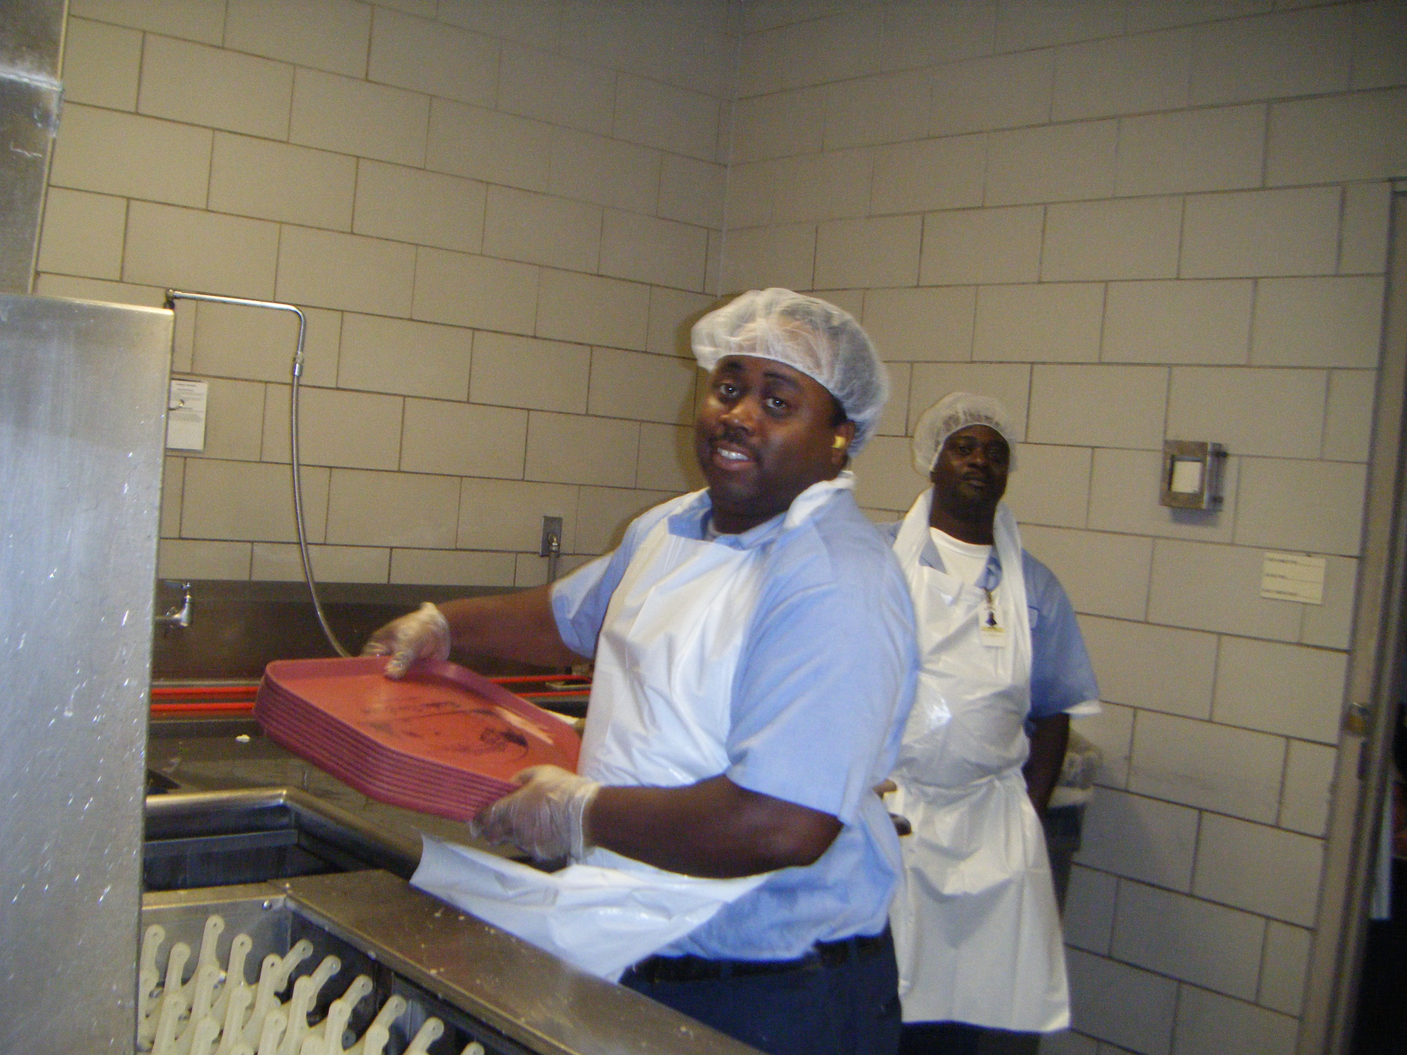

### Vocational Process

* Case Manager completes a Vocational Referral
* Case Manager schedules an appointment with an Employment Specialist on the Vocational Team
* Employment Specialist meets with the Work Candidate and any family/friend supportive to them in starting their career.
* Vocational Profile is started
* Vocational Plan is developed and Employment Process begins

**Information needed to begin employment:**

* Valid Picture ID
* Social Security Card